User Guide – ogusb-lite-0.11

1 Programming the device EEPROM with VID and PID

- When plugged in the board should enumerate as a “USB Device” with VID=0x04B4 and PID 0x8613, however if it enumerates as a “HP Digital TV Tuner Firmware Loader” see section 3 below
- When asked for a driver use: install/sige_no_eeprom.inf
- Load the Cypress bootloader (Vend_Ax.hex) by running the batch file bin/loader.bat
- Program the board with the new VID/PID by running bin/program_vendor.bat
- Run bin/read_vendor.bat to ensure that the programming worked, the first eight bytes of the eeprom should be:

- EEPROM[0:7] = {0xC0, 0xC0, 0x16, 0x2F, 0x07, 0x01, 0x00, 0x01}

- Unplug and plug the board back in, it should now enumerate with VID=0x16C0 and PID=0x072F
- When asked for a driver use: install/sige_ek3.inf

Note: use scan.bat at any time to detect usb devices associated with libusb.

2 Running the ogusb software

- Make sure the device is installed (sige_ek3.inf) and that it shows up as VID=0x16C0 and PID=0x072F
- Upload the firmware to the device by running bin/program.bat (an example of what the output looks like can be found in install/programming.log)
- Collect data by running bin/run.bat, data will be stored to bin/gnss.bin in the same directory

Note: if an attempt is made to collect data when the device is not programmed the following error message will be displayed:

error in usb_fx2_configure,
usb_claim_interface: could not claim interface 2, interface is invalid

3 HP Digital TV Tuner Problem

- If the device enumerates as “HP Digital TV Tuner Firmware Loader” and then gets listed as an unknown device the following steps must be taken
- Run the install/fix.reg file
- Start windows device manager (System -> Hardware -> Device Manager)
- Show hidden devices (View -> Show hidden devices)
- Locate the “HP Digital TV Tuner Firmware Loader” under Universal Serial Bus Controllers, see figure below:

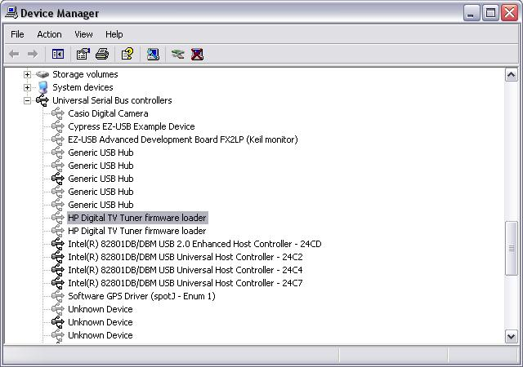

- Update the driver with install/sige_no_eeprom.inf and then disconnect and re-connect the device
- Continue with step 3 in section 1

